1. The JPasswordField class.
It is a swing class very similar to JTextField but with two different characteristics:
- The visual aspect: what the user types is not shown, instead they will see asterisks.
- To access the contents of the JPaswordField it is preferable to use the getPassword () method that returns an array of char. Even though it is also possible to use the getText () method, it is not recommended since it is obsolete. Therefore, an example of use could be:

JPasswordField p = new JPasswordField ();
char [] vc;
………………… ..
vc = p.getPassword ();

2. Images and Swing classes.
On some occasions we have already used images to load them into objects, specifically in a JLabel. Most swing components have a setIcon () method that allows an image to be loaded into the object. For example, if I want to load an image into a JButton I can do:

JButton button = new JButton ();
ImageIcon image = new ImageIcon (getClass (). GetResource ("/ images / image.jpg"));
boton.setIcon (image);

If I want to use an image vector:

JButton button = new JButton ();
ImageIcon imgs [] = new ImageIcon [3];
imgs [0] = new ImageIcon (getClass (). getResource ("/ images / image1.jpg"));
imgs [1] = new ImageIcon (getClass (). getResource ("/ images / image2.jpg"));
imgs [2] = new ImageIcon (getClass (). getResource ("/ images / image3.jpg"));
boton.setIcon (img [0]);

Since I have used a relative path, the images folder must be inside the src folder of the NetBeans project.

3. Exercise.
This week's exercise is the typical hangman game, I have attached a jar version (java executable) so you can see what it consists of:
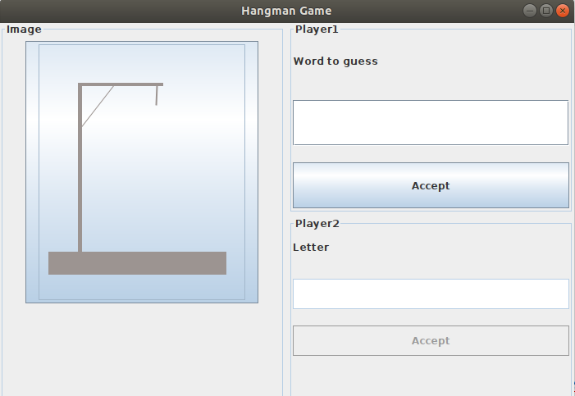

Player 1 will put a word to guess. Player 2 will have its components disabled until player 1 does not accept:
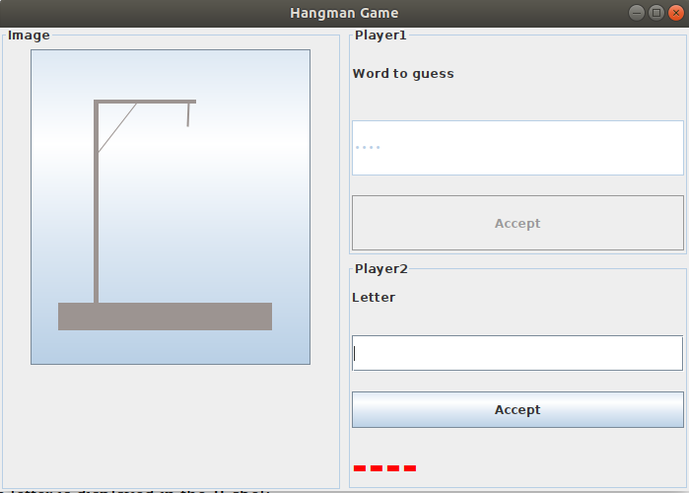

Notice that it also shows a JLabel with a hyphen for each letter that has the word to guess.
Player 2 must test letters. In the event of a failure, the image is changed and in the event of a success, the letter is displayed in the JLabel:

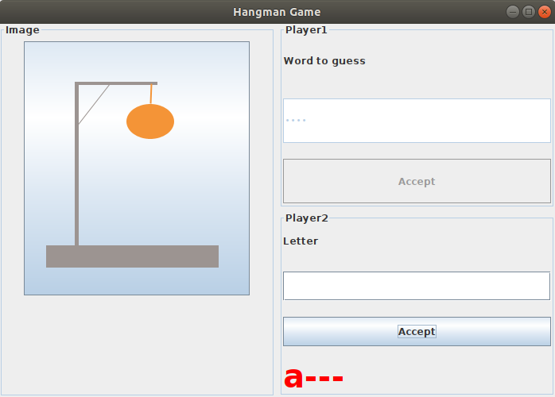

The game ends when player two has had four failures:
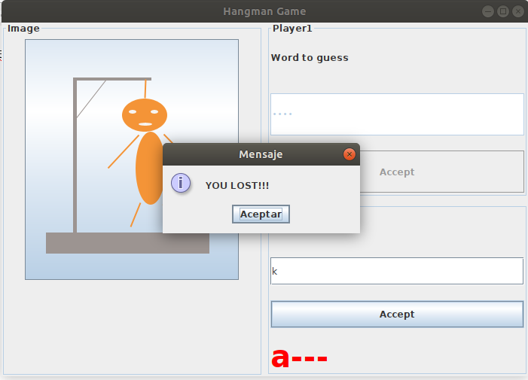

Or when player 2 discovers the word before 4 attempts:

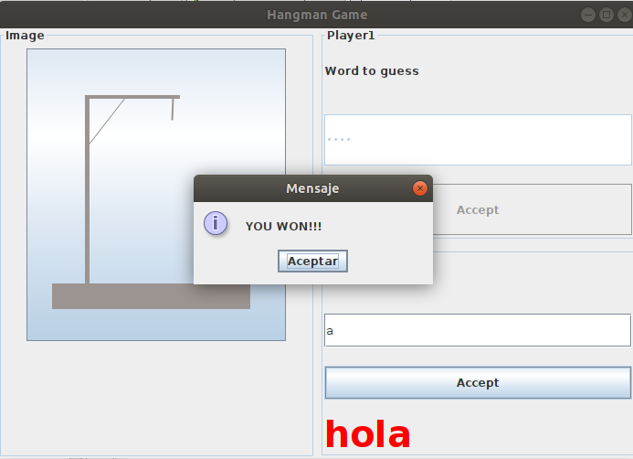

As I said in the previous unit, it is important that you try it alone to practice the exam. I have uploaded the images that I have used in the project.
I will also upload the solved project.

